# CREDIT CARD FRAUD ANALYSIS

**Problem statement:**

It is important that credit card companies are able to recognize fraudulent credit card transactions so that customers are not charged for items that they did not purchase.

**Notebook:**

<https://www.kaggle.com/code2learn/credit-card-fraud-analysis/notebook>

**Algorithms used:**

K nearest neighbor: For classification

Decision Tree: To predict the class or value of target variable

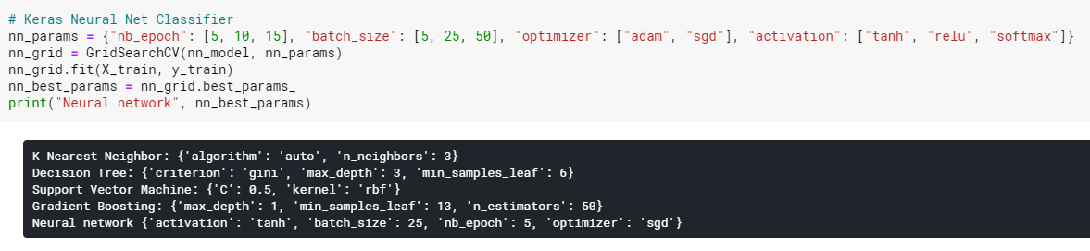

Out of all these algorithms, Support Vector Machine has the highest score.

**Result:**

final output:

